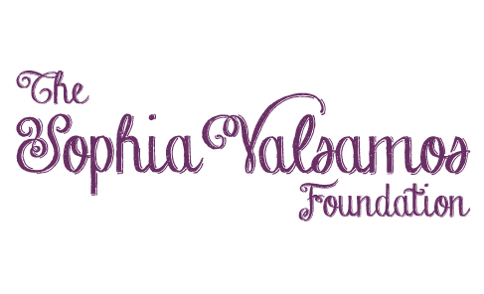

Junior Board Guidelines

PURPOSE: The purpose of The Sophia Valsamos Foundation (TSVF) Junior Board is to gain youth input and perspective on their peer’s challenges. The Junior Board will identify, develop and provide input to programming to be delivered and/or sponsored by the foundation. Additionally, the Junior Board will assist in fundraising activity to support the foundation in its mission. The Junior Board will be comprised of 8 youth/teens.

GOALS:
- Grow TSVF’s youth outreach and community engagement
- Promote healthy communication between peers
- Provide for an opportunity for youth and teen participation in the foundation through specific projects, as well as by providing input to the Board of Directors

OBJECTIVES:
- Junior Board Ambassadors will engage other youth and teens in their schools and community with three (3) events in support of programming and/or fundraising efforts for TSVF
- Complete a minimum of 20 hours of service each school year (September through August) in support of TSVF
- Develop strong and healthy partnerships with fellow youth, teens and adults
- Develop effective communication and leadership qualities

RESPONSIBILITIES AND EXPECTATIONS:
- Youth who are enrolled in 7th through 12th grades can submit an application for consideration
- Commit to attend a minimum of four (4) of the (6) yearly Junior Board meetings
- For each meeting, the youth will identify a meeting lead to run the meeting and a note taker who will be responsible to produce meeting minutes. Members can take turns at various meetings for each of these roles. At some point in the future, a President and Vice President can be named.
- Meetings will be overseen by one TSVF Organization adult member
- The Junior Board will meet with the TSVF Organization two (2) to four (4) times per year
- Create and facilitate three (3) school or community events, as approved by the TSVF organization
- Mandatory attendance at the annual dinner, providing some volunteer time during the event
- Responsible for completing 20 hours of volunteer work, including the events mentioned above
- Ambassadors will demonstrate independent leadership among their peers, versus a “going with the crowd” mindset.
- Ambassadors will conduct themselves in an admirable manner in their school, community and in their use of social media so that they clearly reflect the vision for the foundation.
- Junior Board Ambassadors can be removed at any time by a TSVF Org member if they are not meeting minimum requirements or conducting themselves in a manner suitable with the foundations expectations.

Junior Board Ambassador Application
Last Name |  |  |  | First Name
Date of Birth |  |  |  | Age
School Name |  |  |  | Grade
Street Address |  |  |  | Town, Zip
Phone |  |  |  | Email Address
Explain your interest in getting involved with The Sophia Valsamos Foundation.

What would you like to see the foundation accomplish?

In what capacity to you see yourself participating?

What do you consider your strengths?

What activities do you participate in regularly?

What is your availability?

Youth Signature |  |  | Date
Parent Name |  |  | Parent Phone
Parent Signature |  |  | Date

* Please complete the form and submit to info@tsvf.org by August 1, 2018.

